ASP.NET Core Web API – Hands-on 4
Aim: To implement the PUT action method in an ASP.NET Core Web API to update employee details using the FromBody attribute and return appropriate HTTP responses.
Theory:
- PUT Method: The PUT method is used to update an existing resource on the server.
- FromBody Attribute: The FromBody attribute binds the incoming JSON request body to a C# model object.
- ActionResult: ActionResult allows the API to return different HTTP responses such as 200 OK and 400 Bad Request.
Procedure:
- Open the existing WebApiDemo project.
- Modify the EmployeeController.
- Create a static list of employees.
- Implement the GET method to retrieve employee details.
- Implement the PUT method using the FromBody attribute.
- Run the application.
- Open Swagger.
- Execute the PUT method with a valid employee ID.
- Verify the updated employee details.
- Execute the PUT method with an invalid employee ID and observe the error response.
EmployeeController.cs:
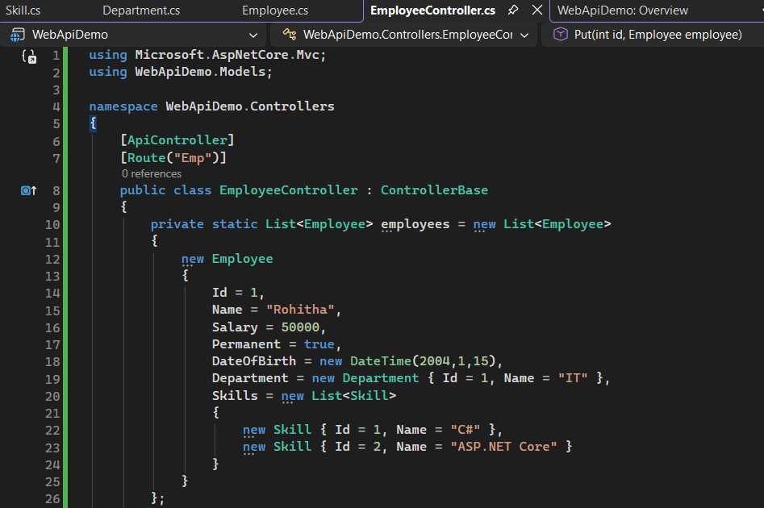
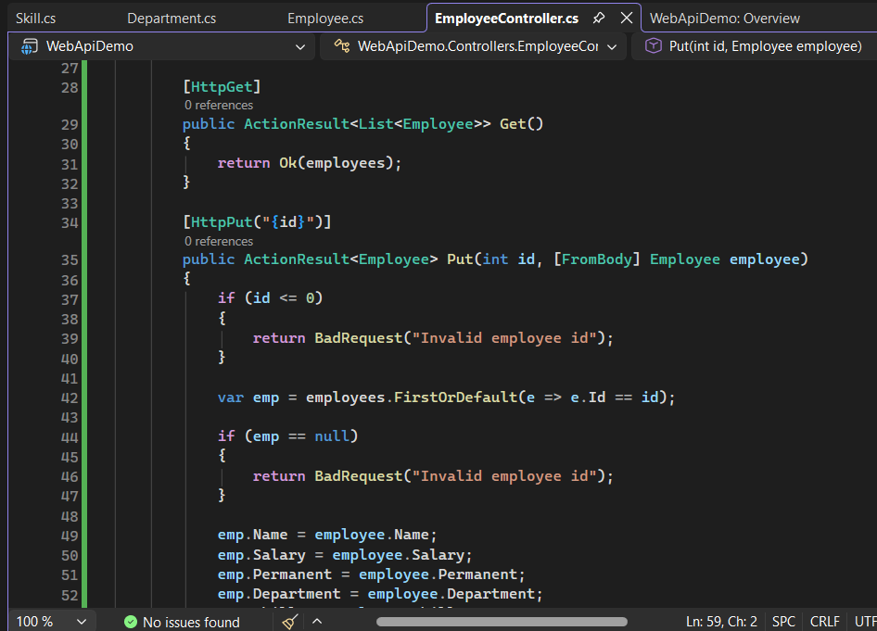

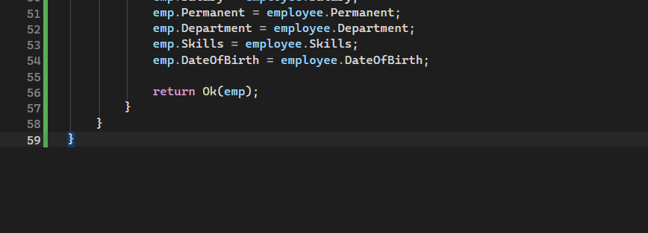
Output:
Valid Request:
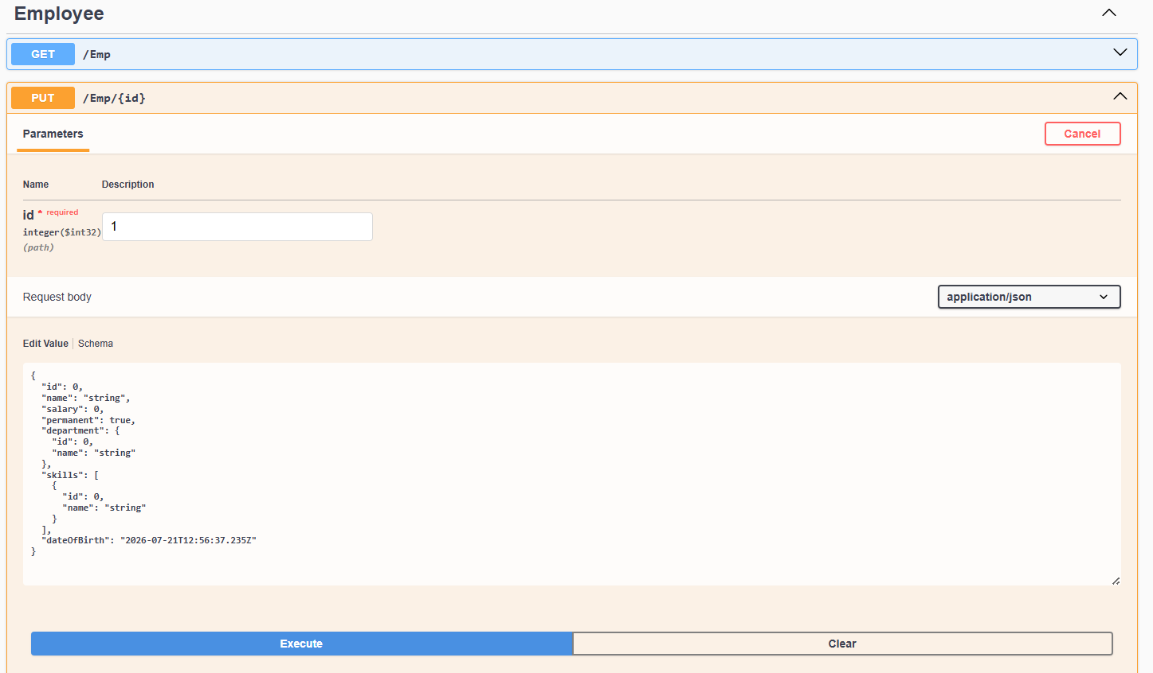

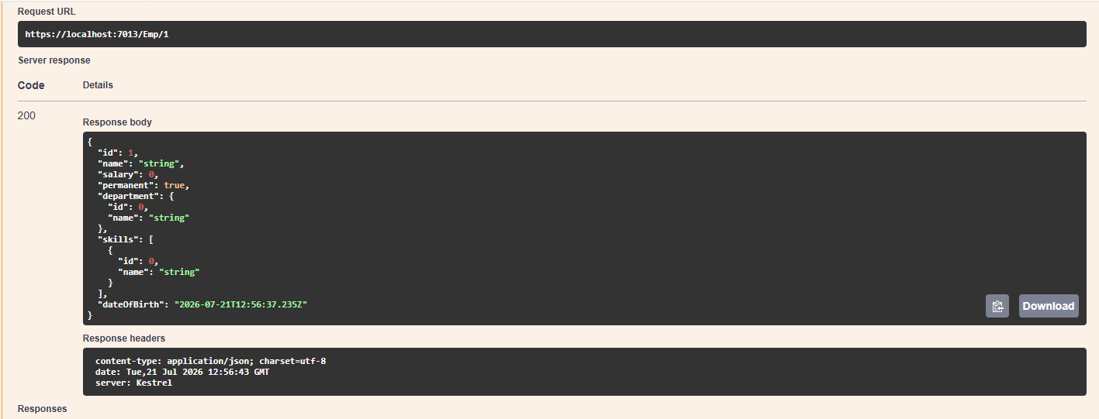
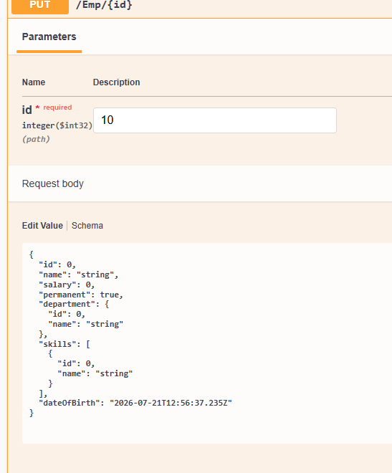
Invalid Request:
